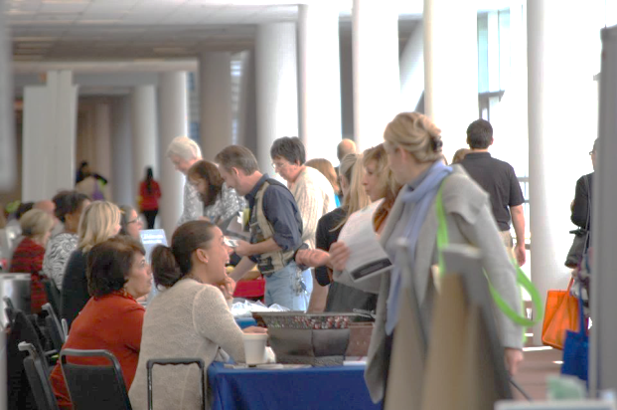­­­

Bi-Annual Resource Fair for Service Professionals

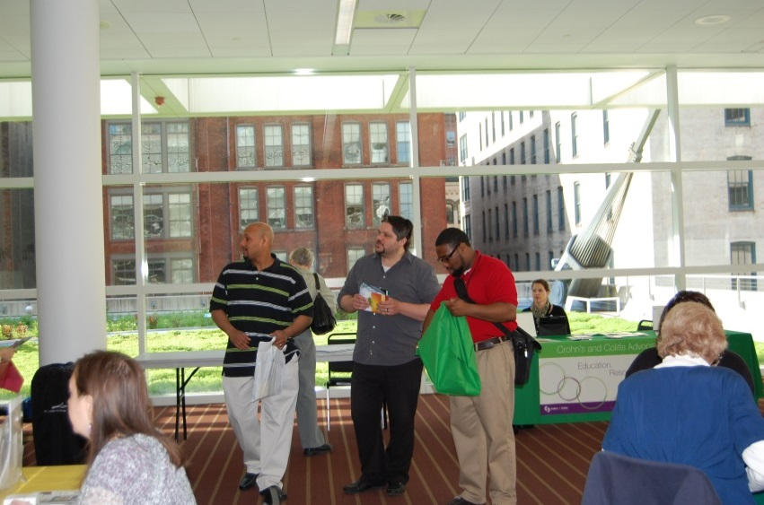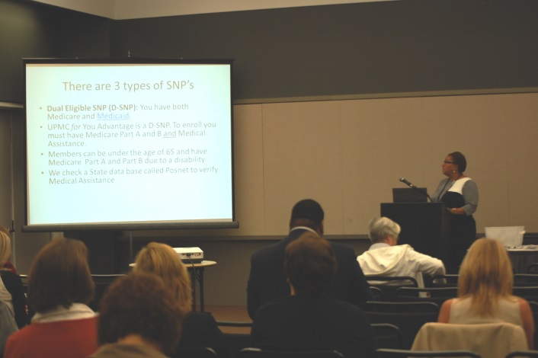

**Exhibitors**

If your company or organization relies on outreach to service professionals then exhibiting at the Where to Turn Resource Fair is the perfect opportunity!

**~**

To become an exhibitor visit our website or call Erin Hart for more information.

412-563-7807

**Visit American-HealthCare.net for More Information.**

* Impact of Health Care Reform
* Housing Resources
* Food/Nutrition information
* Stress Management Programs
* Tobacco Cessation
* Senior Wellness/Age in Place
* Services for Families in Need
* Transportation Resources
* Health Services for Uninsured/Underinsured
* Wellness/Prevention

Speaker Topics Include:

May 5 & October 13, 2015

**8am-12pm**

At the David L. Lawrence Convention Center in downtown Pittsburgh, PA